**Functional requirement of information sharing application**

# Objective :

The objective of the web platform for information sharing between organizations is to provide a secure and efficient platform that enables seamless sharing of data and promotes collaboration among different organizations.

# Features Supported in Application

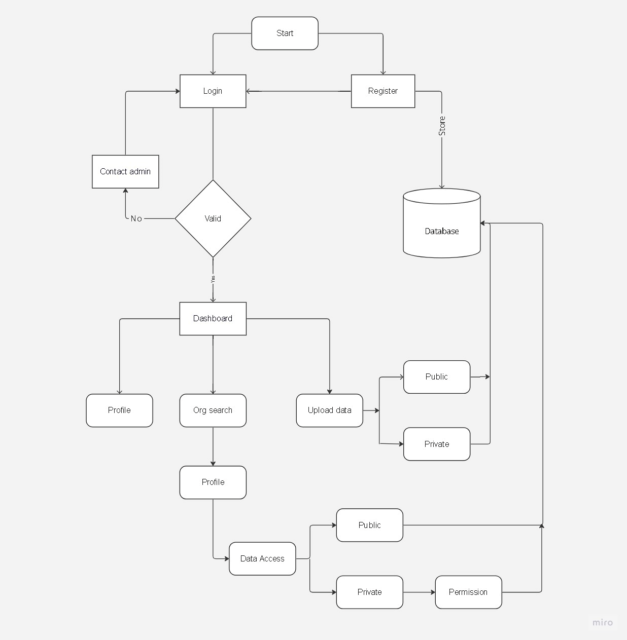

**Features for Admin :**

|  |  |
| --- | --- |
| **Field Name** | **Description** |
| User Management | Manage user accounts, roles, and permissions. |
| System Configuration | Setting up and customizing platform setting to optimize performance and meet organizational requirements. |
| Data Management | Handling and organizing data files, ensuring quality, compliance, and effective use within the platform. |
| System Maintenance | Performing routine tasks to ensure platform functionality, stability, and security through maintenance, updates, and monitoring. |
| Communication and Support | Facilitating effective communication between users to address inquiries and resolve issues. |

# Admin Interactions :

1. Admin logs in to the Admin Dashboard.

2. Admin manages user accounts, system settings, and shared data.

3. Admin controls access permissions for shared data.

4. Admin performs maintenance and supports users.

5. Admin generates reports and ensures platform governance.

6. Interaction concludes.

**Features for Users :**

|  |  |
| --- | --- |
| **Field** | **Description** |
| User  Registration/Login | Create a new user account by providing necessary information for platform access.  Authenticate and access the platform using registered credentials for personalized user experience. |
| Data Upload and categorization | Users can upload files and categorise it as private or public |
| Collaboration and Communication | Users can collaborate with other organizations through document sharing features. |
| Access Requests | Users can send access requests to other organizations to gain access to their private data.. |
| Notifications | Users receive notifications for activities such as access requests, and approvals. |

**User’s Interactions :**

Start --> User Registration --> Organization Profile Setup --> Data Upload and Management --> Data Sharing

|

|--- Access Request and Approval --> Data Owner Approval --> Access Granted

|

|--- Data Discovery and Search --> Search and Filter Data

|

|--- Collaboration and Communication --> Share Documents

|

|--- Notifications and Alerts --> Customize Notification Preference

|

|--- Support and Help --> Access Help Documentation and Seek Assistance

|

|--- Data Privacy and Security --> Ensure Data Confidentiality and Compliance

End